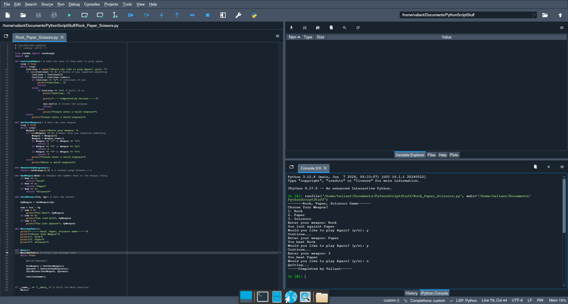

from random import randrange

import sys

def ContinueGame(): # asks the user if they want to play again

loop = True

while loop:

Continue = input("Would you like to play Again? (y/n): ")

if len(Continue) != 0: # Checks if you inputted something

Continue = Continue[0]

Continue = Continue.lower()

if Continue == "y": # continues if yes

print("Continue...")

return

else:

if Continue == "n": # Quits if no

print("Quiting...")

print("-----Completed by Valiant-----")

sys.exit() # Closes the program

return

else:

print("Please enter a valid responce")

else:

print("Please enter a valid responce")

def GetUserWeapon(): # Gets the user weapon

loop = True

while loop:

Weapon = input("Enter your weapon: ")

if len(Weapon) != 0: # Makes sure you inputted something

Weapon = Weapon[0]

Weapon = Weapon.lower()

if Weapon == "1" or Weapon == "r":

return 1

if Weapon == "2" or Weapon == "p":

return 2

if Weapon == "3" or Weapon == "s":

return 3

print("Please enter a valid responce")

else:

print("Enter a valid responce")

def GenerateOpResponce():

return randrange(1,3) # a random range between 1-3

def GenWeapon(Num): # changes the number back to the weapon thing

if Num == 1:

return "Rock"

if Num == 2:

return "Paper"

if Num == 3:

return "Scissors"

def CalcWinner(You, Op): # Cals the winner

OpWeapon = GenWeapon(Op)

num = You - Op

if num > 0:

print("You beat", OpWeapon)

if num == 0:

print("You tied with", OpWeapon)

if num < 0:

print("You lost against", OpWeapon)

def WelcomeText():

print("-------Rock, Paper, Scissors Game------")

print("Choose Your Weapon!")

print("1. Rock")

print("2. Paper")

print("3. Scissors")

def Main():

WelcomeText() # Prints the welcome text

while True:

#print(Openent)

UsrWeapon = GetUserWeapon()

Oponent = GenerateOpResponce()

CalcWinner(UsrWeapon, Oponent)

ContinueGame()

if __name__ == "__main__": # Calls the Main function

Main()